Ideation Phase
Empathize & Discover

Date | 26 June 2025
Team ID | LTVIP2025TMID34134
Project Name | Pollen's Profiling: Automated Classification of Pollen Grains
Maximum Marks | 4 Marks

Empathy Map Canvas:
An empathy map is a simple, easy-to-digest visual that captures knowledge about a user’s behaviours and attitudes.
Empathy allows us to see the world through the eyes of our users—environmental scientists, medical professionals, and agricultural researchers. By understanding their challenges, emotions, and goals, we can create a solution that is not just functional, but truly helpful and human centered .
Example:
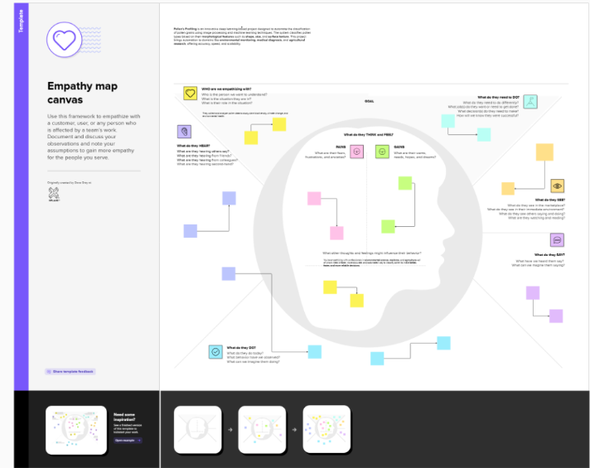

Example: 